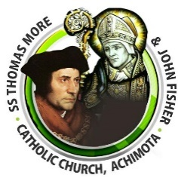

P.O. BOX AH 283, Achimota-Accra Website*:* [*www.thomasmorejohnfisher.com*](http://www.thomasmorejohnfisher.com/) Email*:besohwe@yahoo.com*

**SS. THOMAS MORE AND JOHN FISHER CATHOLIC CHURCH, ACHIMOTA.**

**WEEKLY NEWSLETTER**

**TODAY’S READINGS**

***First Reading****:* **Wis. 11:22-12:2**

God is merciful because all things were created by God.

***Responsorial Psalm:* Ps 145:1-2, 8-11, 13-14**

**I WILL BLESS YOUR NAME FOR EVER, MY KING AND MY GOD.**

***Second Reading:* 2Thes 1:11-2:2**

Paul tells the Thessalonians to remain faithful to Christ until Christ comes again.

***Gospel Reading:* Lk 19:1-10**

Jesus stays at the house of Zacchaeus, the tax collector.

**Reflection**

Zacchaeus a tax collector and wealthy man, for that matter, shows himself to be someone in search of salvation. Zacchaeus, described as short in stature, climbs a tree in order to see Jesus. In his search for salvation, he humbled himself by making a spectacle of himself by climbing a tree. Again, He disregards his status, wealthy and dignified a man as he was to climb a tree which is a common activity of children in order to encounter Christ who saves Jesus recognizes the faith and dare of this tax collector exhibited in his search for salvation and calls him down from the tree. Like Zacchaeus may we be filled with enthusiasm and determination in search of our salvation.

May we put aside our pride to encounter our Lord.

**Weekly Readings**

|  |  |
| --- | --- |
|  | |
| **Mon 31ST OCTOBER, 2022**  Phil. 2:1-4  Ps 131:1-3  Lk 14:12-14 | **Tue 1ST NOVEMBER, 2022**  **All Saints**  Rev 7:2-4,9-14  Ps 24:1-6  1Jn 3:1-3  Mt 5:1-12a |
| **Wed 2ND NOVEMBER, 2022**  **The Commemoration of All the Faithful Departed (All Souls)**  Wis. 3:1-9  Ps 22:1-6  Rom 5:5-11 or 6:3-9  Jn. 6:37-40 | **Thurs 3RD NOVEMBER, 2022**  **St Martin de Porres, religious**  Phil 3:3-8a  Ps 105:2-7  Lk 15:1-10 |
| **Fri 4TH NOVEMBER, 2022**  **St. Charles Borromeo, bishop**  Phil 3:17-4:1  Ps 122:1-5  Lk 16:1-8 | **Sat 5TH NOVEMBER, 2022**  Phil 4:10-19  Ps 112:1-2,5-6,8-9  Lk 116: 9-15 |

|  |  |
| --- | --- |
| **Readings for Next Sunday** | |
| **First Reading** | **2Mac 7:1-2,9-14** |
| **Responsorial Psalm** | **Ps 17:1,5-6,8b** |
| **Second Reading** | **2Thes 2:16-3-5** |
| **Gospel** | **Lk 20:27-38 or 20:27,34-38** |

|  |  |
| --- | --- |
| **Mass Schedule** | |
| ***St. Thomas More*** | ***St. John Fisher*** |
| **First Mass: 7:00 AM** | **First Mass: 6:30 AM** |
| **Second Mass: 9:30 AM** | **Second Mass: 9:30 AM** |

**30TH OCTOBER, 2022: THIRTY-FIRST SUNDAY IN ORDINARY TIME, YEAR C.**

**THEME FOR THE WEEK:** “DARE IN FAITH TO SEE THE LORD’’

Rev. Fr. George Obeng Appah *(Parish Priest)* **020-8592020**

Rev. Fr. Emmanuel Kwofie (Assistant Priest) **020-6355610**

St. Thomas More Catholic Church - **030-3931800**

SS. Thomas More and John Fisher Catholic Church - **030-3939862**/

**030-2436199**

**PRAYER FOR GOD’S INTERVENTION IN OUR LAND CASE**

**KNOW MORE ABOUT YOUR FAITH**

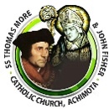

Almighty and Merciful Father, we thank you for our faith and for the gift of our church community. We thank you for how far you have brought us as a parish. You have been our refuge in times past and our hope for years to come.

We humbly beseech you to help us win back our Land in this dispute. Save us from violence, discord and confusion and the evil plans of our adversaries.

For the Court of Justice, we pray that you will give them the spirit of Wisdom and Understanding that they may discern the truth and impartially administer the law in the fear of you alone. May they not yield to deceit and acts of bribery and corruption but uphold the truth and let justice prevail.

May your Mother Mary intercede for us and may the Archangel Michael defend us in battle. We make our payer through Christ our Lord and Redeemer.

Amen.

St. Thomas More………. Pray for us

St. John Fisher…………... Pray for us

All you Angels and Saints …… Pray for us

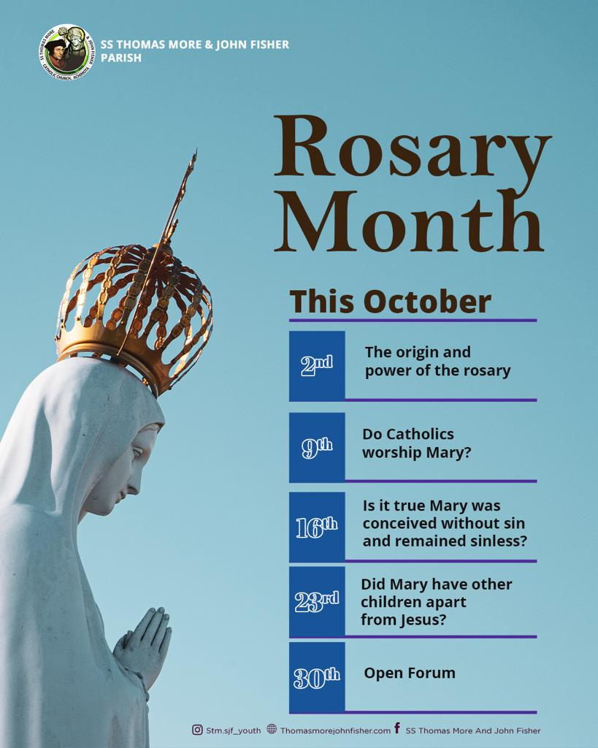

**OCTOBER TEACHINGS**

**MARKS OF THE CHURCH**

**CATHOLIC**

The Church is also “catholic,” meaning it is universal. Here we are speaking of catholic with a small “c.” By “universal” we mean two things:

1) The Church is first of all complete. In the Church is the fullness of salvation because in the Church is Christ Jesus. So, it is universal, full and complete because the Church is the Body of Christ.

2) The Church is also universal insofar as it is open to all people and is sent to bring all people into her fold. We have a mission to evangelize and to invite everyone into the fold of Christ. You do not have to be born into the Church, rather, you have to be reborn into Christ, and it is this act that is open to all. So, what about all those non-Catholics? Or what about the non-Christians? What about the Muslims, Jews, and even atheists? Is there any hope for them?

Let’s start with the atheist. One of the Vatican II documents explains it this way:

Those who, through no fault of their own, do not know the Gospel of Christ or his Church, but who nevertheless seek God with a sincere heart, and, moved by grace, try in their actions to do his will as they know it through the dictates of their conscience—those too may achieve eternal salvation (LG 16; cf. DS 3866–3872). (CCC #847)

A classic example of this is the person born and raised on a deserted island. They never heard of Jesus, the Scriptures or even God. But, nonetheless, they perceived a still small but clear voice in their conscience to “do this” and to “avoid that.” If they listen, they are responding to grace. If they do not, they are rejecting salvation. And if they do respond, they are, in a very real way, an anonymous Christian whether they realize it or not! So if an atheist is an atheist “through no fault of his own,” then he can be saved. If, however, he is an atheist because of a hardness of heart and a refusal to listen even to the voice of God in his conscience, then he will not be saved.

***To Be Continued…***

**UPCOMING EVENT**

20

2022 HARVEST

SUNDAY 6TH NOVEMBER

STM: MASS @ 7.00AM

SJF MASS @ 6.30AM & 9.30AM

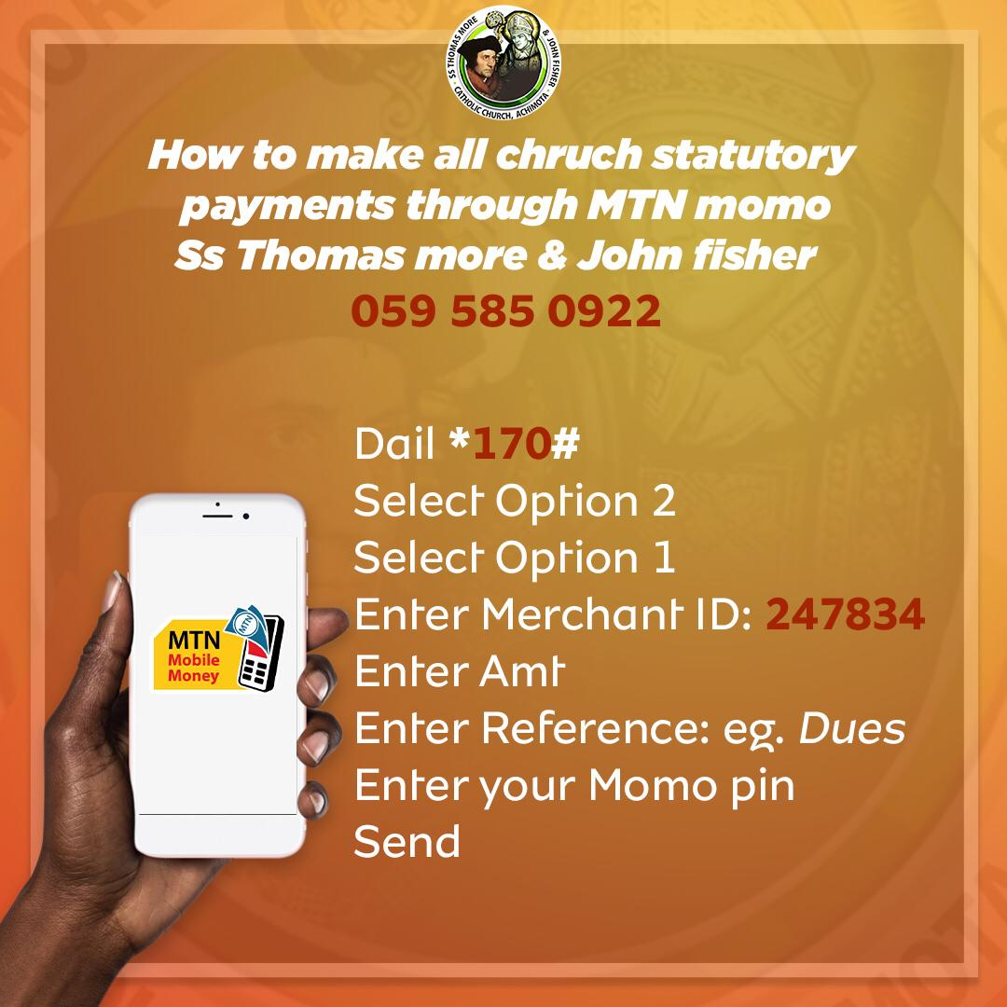

**MOTIVATION**

**LIFE**

**Nothing can pull you down if you remain strong and positive throughout your life.**

**Life will provide you with challenges; you must have a fighting spirit at all times.**

**Do what make you happy rather than what everyone else wants you to do.**

**As long as you believe in yourself, you can do anything.**

**Life is a package full of surprises. It has good and bad stored for you. Just keep moving forward and never give up.**

**Life is short, so make every step of your life count.**

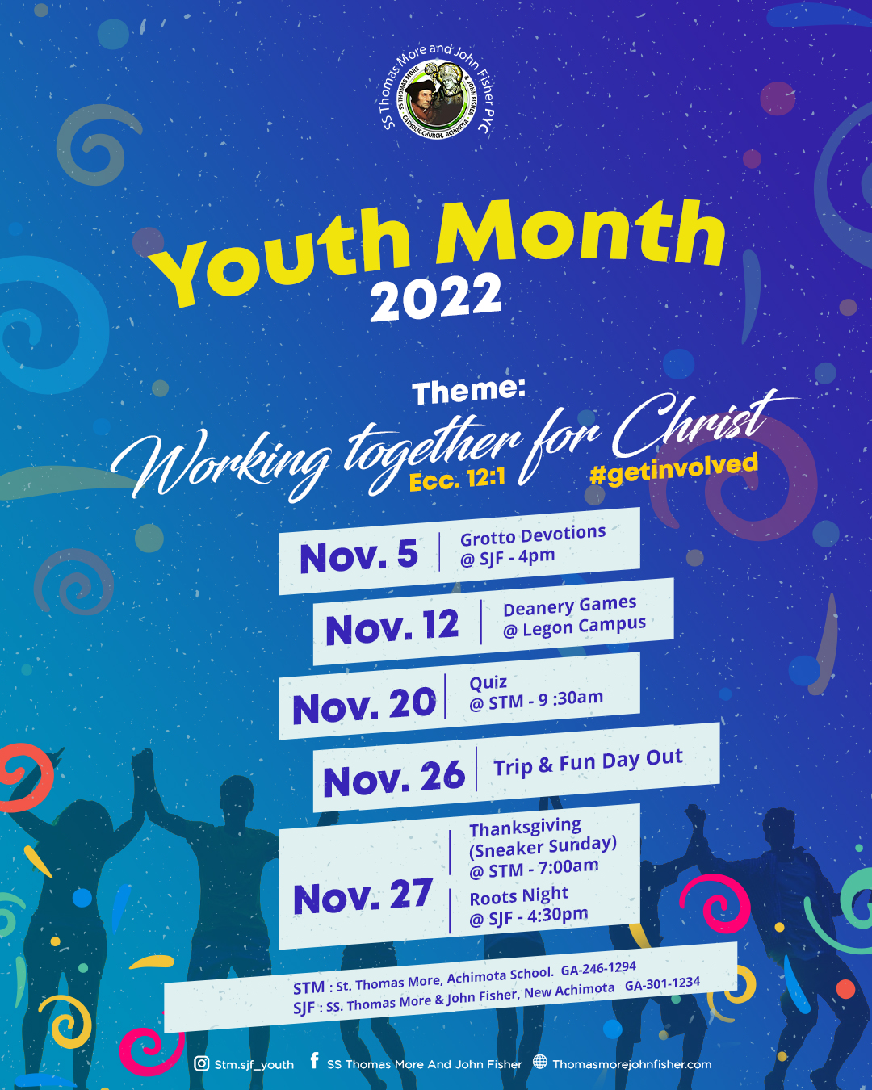

**YOUTH CORNER**

**ANNOUNCEMENTS**

**PASTORAL CARE**

1. We are reminded of this year’s Harvest which comes off on the 6th November, 2022. There will be one Mass @7:00am @STM and two Masses @SJF. (6:30am & 9:30am). We are reminded to pay our Harvest Levy of GH¢100 per adult, GH¢50 per working youth, GH¢20 per child or more and also redeem our Pledges.

2. The Health committee will be organizing a first aid training. Any parishioner who is interested should give details of their names, phone number and Mass they normally attend, to any of the church secretaries.

3. Tuesday 1st November is the Solemnity of All Saints. There will be morning mass at STM at 6.15am and evening mass at SJF at 7.00pm

4. Wednesday 2nd November is All Souls day. There will be morning mass at STM at 6.15am and evening mass at SJF at 7.00pm. We are encouraged to request mass for our deceased relatives.

5. The funeral arrangement of the late Mad. Elizabeth Dogbey is as follows:

* Laying In State: Friday 11th November, 2022 at her residence, New Achimota, Kingsby roundabout down. Hse no. 55/27b, oil lane9
* Burial and funeral rites: Saturday 12th November, 2022. Attire: Black & White.
* Thanksgiving Service: Sunday 13th Nov. at SJF at 9:30am. Attire: All White.

**Sacrament of Confession:** Every Saturday from 5.00pm at SJF and from 6.30pm at STM.

**Sacrament of Baptism of Infants:** *First Saturday of every month. Please call at the Church’s office for a baptismal form. Instructions: Thursday preceding the date for baptism @ 5pm @ STM.*

**Visitation to the Sick and Aged:** *Thursdays at 7.00 am. Contact the office if you have a sick or aged Person(s) to be visited.*

**Sacrament of Marriage:** Arrangements must be made ***at least six months to a year*** with the priests. The couple or one of them must be a registered member of the Church for ***at least 6 months.***

**Consultation of Priests: (STM)** Monday, Tuesday and Thursday (In the Evenings) Time: 6.30 - 8.00 pm**. (SJF) Wednesdays at 5:00pm.** In case of an emergency, call on the Priest.

**CHURCH OFFICE HOURS: Monday to Thursday:**

**9am -1pm & 2 pm - 5pm: and Sunday: 9 am - 1.30pm**

**SLOGAN: Ss. Thomas More & John Fisher: Besohwξ!**

**Ss. Thomas More & John Fisher: Justice and Truth!!**

**Ss. Thomas More & John Fisher: Pray for us!**

**THANKS FOR WORSHIPPING**

**WITH US.**

**HAVE A BLESSED WEEK.**

**FINANCE CORNER - ST. THOMAS MORE**

|  |  |  |  |
| --- | --- | --- | --- |
| **WEEKDAYS** | **STM**  **NOV.**  **WEEK1** | **STM**  **NOV.**  **WEEK2** | **STM**  **NOV.**  **WEEK3** |
| **SUNDAY** | 615.00 | -------- | ------- |
| **MONDAY** | 695.30 | 20.00 | 50.00 |
| **TUESDAY** | 2097.50 | 5.00 | ------- |
| **WEDNESDAY** | 1589.10 | 5.00 | 5.00 |
| **THURSDAY** | 1072.00 | 50.00 | 310.00 |
| **FRIDAY** | 861.00 | 75.00 | ------- |
| **SATURDAY** | 621.90 | 20.00 | ------- |
| **NOV. BORN** | 70.00 | -------- | ------- |
| **TOTAL** | **7621.80** | **175.00** | **365.00** |

**FINANCE CORNER – ST. THOMAS MORE**

|  |  |  |  |  |
| --- | --- | --- | --- | --- |
| **WEEKDAYS** | **STM**  **OCT.**  **WEEK1** | **STM**  **OCT.**  **WEEK2** | **STM**  **OCT.**  **WEEK3** | **STM**  **OCT.**  **WEEK4** |
| **SUNDAY** | 1412.00 | ----- | 20.00 | 20.00 |
| **MONDAY** | 1458.00 | 200.00 | 2.00 | --- |
| **TUESDAY** | 1303.80 | 850.00 | 20.00 | --- |
| **WEDNESDAY** | 544.00 | 710.00 | 5.00 | 50.00 |
| **THURSDAY** | 1321.00 | ----- | 270.00 | 400.00 |
| **FRIDAY** | 1264.70 | 70.00 | 100.00 | 100.00 |
| **SATURDAY** | 721.50 | 20.00 | ---- |  |
| **OCT. BORNS** | 213.00 | ----- | ---- |  |
| **TOTAL** | **8238.00** | **1850.00** | **417.00** | **570.00** |

**yyyy**

**Details of Last Sunday’s**

**Collections**

|  |  |
| --- | --- |
| **SUNDAY** | **STM**  **OCT.**  **WEEK4** |
| **MAIN**  **COLLECTION** | 2190.70 |
| **SECOND COLLECTION** | 1132.50 |
| **TITHE** | 400.00 |
| **TOTAL** | **3323.20** |

|  |  |  |  |  |
| --- | --- | --- | --- | --- |
| **WEEKDAYS** | **SJF**  **OCT.**  **WEEK1** | **SJF**  **OCT.**  **WEEK2** | **SJF**  **OCT.**  **WEEK3** | **SJF**  **OCT.**  **WEEK4** |
| **SUNDAY** | 913.00 | 1.00 | 100.00 | 90.00 + £ 5.00 |
| **MONDAY** | 1646.00 | 1050.00 | 500.00 | ---- |
| **TUESDAY** | 842.00 | 20.00 | ---- | ---- |
| **WEDNESDAY** | 975.00 | 5.00 | 50.00 | 5.00 |
| **THURSDAY** | 1578.00 | 100.00 | 10.00 | ---- |
| **FRIDAY** | 1107.00 | 90.00 | 15.00 | 3570.00 |
| **SATURDAY** | 1408.00 | ----- | 200.00 | ---- |
| **OCT. BORNS** | 286.00 | ----- | ---- | ---- |
| **TOTAL** | **8755.00** | **1266.00** | **875.00** | **3665.00 + £ 5.00** |

**yyyy**

**Details of Last Sunday’s**

**Collections**

**THANK YOU FOR ALL YOUR GENEROUS CONTRIBUTIONS**

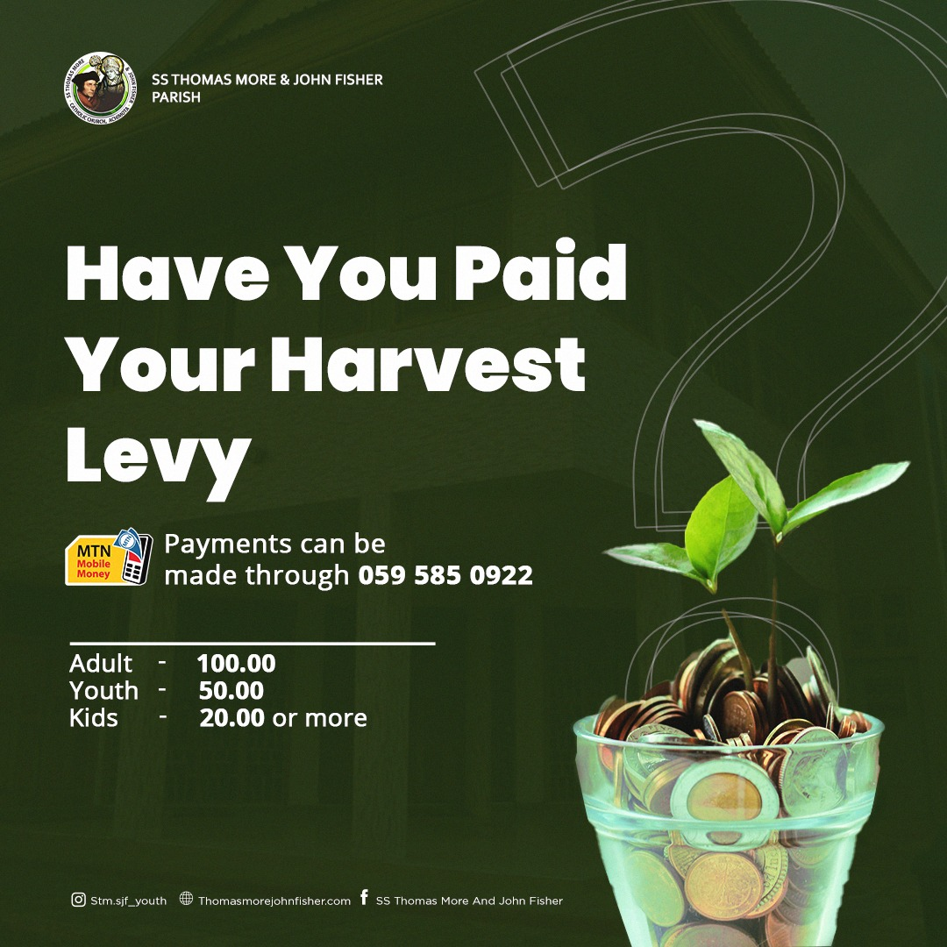 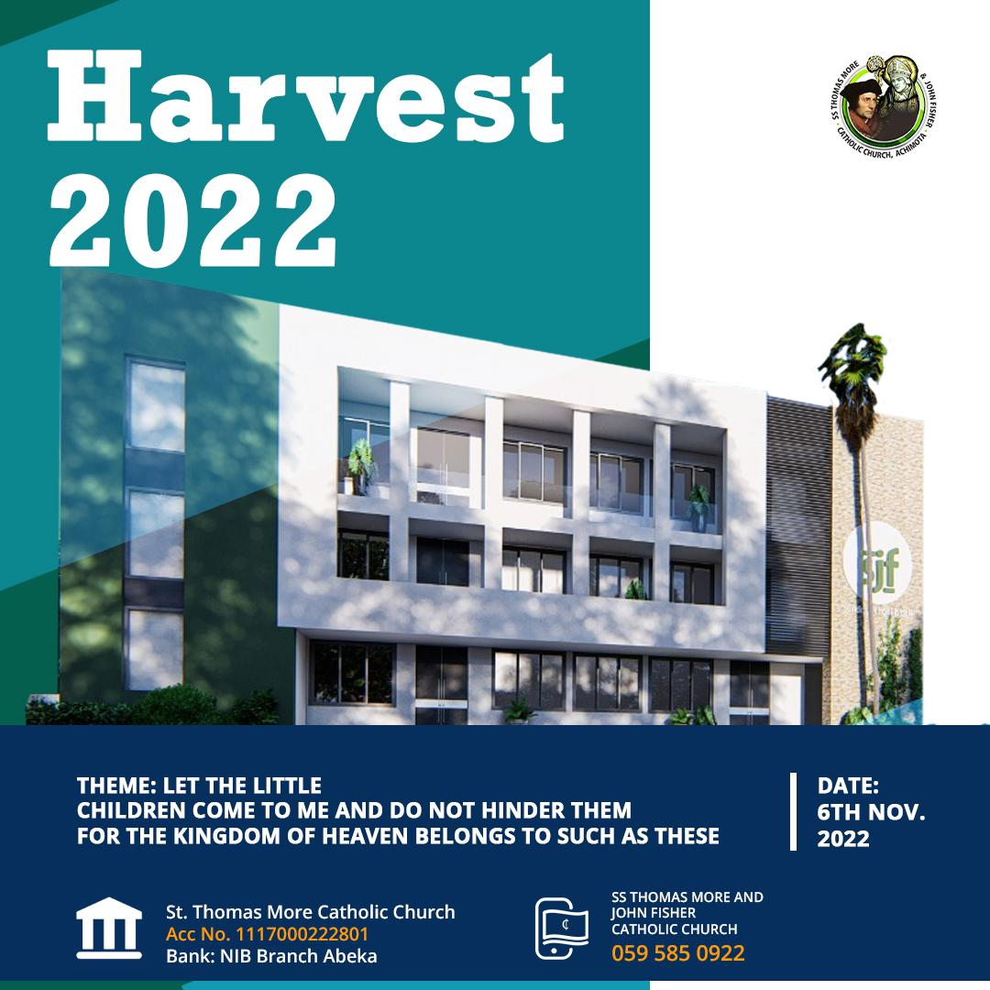

**FINANCE CORNER – ST. JOHN FISHER**

|  |  |
| --- | --- |
| **SUNDAY** | **SJF**  **OCT.**  **WEEK4** |
| **MAIN**  **COLLECTION** | 2718.10  + £ 30.00 |
| **SECOND COLLECTION** | 1879.00 |
| **TITHE** | ------- |
| **TOTAL** | **4597.00**  **+ £ 30.00** |

VEST LEVY OF GH¢100 PEORE PER CHILD.