.
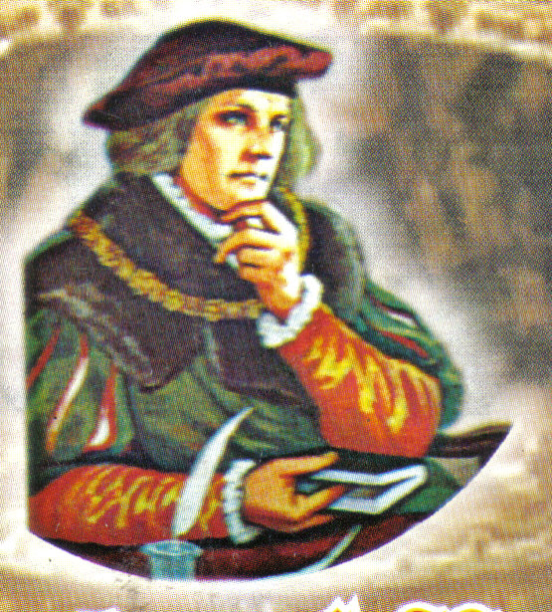

P.O. BOX AH 283, ACHIMOTA-ACCRA
Website: www.thomasmoreachimota.com E-mail:besohwe@yahoo.com Office Tel: 0201-775453,/
Rev. Fr. George Obeng-Appah (Priest-in-charge) Tel: 0208-592020 0303-931800
Rev. Fr. Blaise Bobi-Attachie
WEEKLY NEWSLETTER
8TH DECEMBER, 2013: SECOND SUNDAY OF ADVENT- A 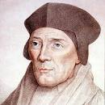
THEME FOR THE WEEK: A Call to Repentance

”
”

”

Theme for the week: “All nations shall adore the Lord”

TODAY’S READINGS

1st Reading: Is 11:1-10
Christ does not judge by appearance or hearsay. He will be just for everybody and fair even to the poor. Therefore there will be peace and happiness.

Responsorial Psalm: 72: 1-2, 7-8, 12-13, 17
IN HIS DAYS SHALL JUSTICE FLOURISH, AND GREAT PEACE FOREVER.

2nd Reading: Rom 15: 4-9
Paul tells us that scripture was written for our instruction, that we might derive hope from it. In Christ is the yearning of people fulfilled.

Gospel: Mat 3:1-12
Preparing for the Lord’s coming and fully accepting him may require a change in life style. John the Baptizer speaks clear language not just to the Jews of his time but to all of us.

Reflection
In Advent, we are called upon to clear the way. Clearing the way for Christ to enter more deeply into our society and our lives means, first of all, repenting. That is what John the Baptist came to assist us to do; to show true repentance. To repent is to turn away from selfish behaviour patterns. To repent means to acknowledge our sins. On this second Sunday of Advent, the prophet, John the Baptizer urges us to repent and more importantly to show the fruits of our repentance.

ANNOUNCEMENTS

- There is Bible sharing this and every Wednesday at STM at 7:00pm.
- There are Good News Bibles are available in the office for sale.
- Hot Sales: House with 21 rooms and a big compound for sale at Kisseman. Please contact 0273419367
- A parishioner needs a two bedroom house for rent urgently around Achimota and its environs. Anyone who can be of help should contact the secretary.
- Publication of Marriage Banns: (1st) Godwin Ofosu and Elizabeth Akua Adzraku
- Funeral Announcement:
The death is reported of Mr. Sylvanus Anku-Vinyo. Details of the funeral are as follows; Burial Mass on 14th Dec 2013. Thanksgiving Mass on 15th Dec 2013 all at St John Fisher Catholic Church.
- Appreciation: We would like to thank all parishioners who in diverse ways helped to make this years’ Harvest a success. God richly bless and reward you abundantly.
QUIZ
Answer to last Week’s: Four

This week’s: Who said: “Mary do not be afraid; you have won God’s favour”?

QUOTE
We make a living by what we get but we make a life by what we give.
- Winston Churchill
HARVEST 2013
- Parishioners are reminded to visit the harvest 2013 information desk to pay their harvest levy of 5 Cedis.

- The tiles for completing the floor space of St. John fisher are still being sold. We are encouraged to purchase them in appreciation of the lives of loved ones. The cost is 20 Cedis per tile. Contact the information desk.

PASTORAL CARE
Sacrament of Confession: Every Saturday from 6.00pm to 7.00pm
Sacrament of Baptism of Infants: First Saturday of every month. Please call at the Church’s office for a baptismal form. Instructions: Thursday preceding the date for baptism.
Visitation of the Sick and Aged: Thursdays at 7.00 am. Contact the office if you have a sick or aged Person(s) to be visited.
Sacrament of Marriage: Arrangements must be made at least six months to a year with the priests. The couple or one of them must be a registered member of the Church for at least 6 months.
Consultation of Priests: Monday, Tuesday Wednesdays (In the Evenings) Time: 6.30 - 8.00 pm. In case of any emergency call on the Priest.
Church office hours: Mon. to Thur.:10am -2pm & 5 pm - 8pm: Sat. 6 pm to 8pm: Sun: 9 am -1.30pm: Friday: Off Duty

SUNDAY MASS: FIRST MASS - 7:00AM AT STM, SECOND MASS - 9:30AM AT SJF

NEXT SUNDAY: THIRD SUNDAY OF ADVENT
Singing: First Mass: Main Choir

Second Mass: Chari SM

Offertory and Bidding Prayers:
First Mass: New Achimota Community

Second Mass: Amalgamated Society

WEEKDAY MASS

Monday 7:00pm
Tuesday 6:15am
Wednesday 6:15am
Thursday 6:15am

UPCOMING EVENTS
- Advent Retreat 18 – 20 Dec 2013 Theme: “Preparing for the Christ Child; Praying with Isaiah”
- Nine Lessons & Carols 24th Dec 2013
- Encounter with Jesus 29th Dec 2013

SLOGAN: St. Thomas More: Besohwe! St. Thomas More: Justice and Truth!!
St Thomas More: Pray for us!!!

SLOGAN: St John Fisher: Besohwe!
St John Fisher: Justice and Truth!!
St John Fisher: Pray For Us!!!

THANKS FOR WORSHIPPING WITH US. HAVE A BLESSED WEEK.

READINGS FOR THE WEEK
- Mon 9th December, 2013
(Immaculate Conception)
Gen 3:9-15, 20; Ps 98:1-4; Eph 1:3-6, 11-12; Mat 8:5-11

- Tues 10th December, 2013
Is 40:1-11; Ps 96:1-3, 10-13;
Mt 18:12-14

- Wed 11th December, 2013
Is 40:25-31; Ps 103:1-4, 8, 10;
Mat 11:28-30

- Thur 12th December, 2013
Is 41:13-20; Ps 145:1, 9-13;
Mat 7:21, 24-27

- Fri 13th December, 2013 ( St. Lucy)
Is 48:17-19; Ps 1:1-4, 6;
Mat 11:16-19

- Sat 14th December, 2013
(St. John of the cross)
Sir 48:1-4, 9-11; Ps 80:2-3, 15-16, 18-19
Mt 17:10-13

15TH DECEMBER, 2013
THIRD SUNDAY OF ADVENT

1st Reading: Is 35:1-6; 10

Resp. Ps : 146:6-10

2nd Reading: Jas 5:7-10

Gospel : Mt 11:2-11

KNOW MORE ABOUT YOUR FAITH

HISTORY OF THE FEAST OF THE IMMACULATE CONCEPTION:
The Feast of the Immaculate Conception, in its oldest form, goes back to the seventh century, when churches in the East began celebrating the Feast of the Conception of Saint Anne, the mother of Mary. In other words, this feast celebrates the conception of the Blessed Virgin Mary in the womb of Saint Anne; and nine months later, on September 8, we celebrate the Nativity of the Blessed Virgin Mary.
As originally celebrated (and as still celebrated in the Eastern Orthodox Churches), however, the Feast of the Conception of Saint Anne does not have the same understanding as the Feast of the Immaculate Conception has in the Catholic Church today. The feast arrived in the West probably no earlier than the 11th century, and at that time, it began to be tied up with a developing theological controversy. Both the Eastern and the Western Church had maintained that Mary was free from sin throughout her life, but there were different understandings of what this meant.
DEVELOPMENT OF THE DOCTRINE: Because of the doctrine of Original Sin, some in the West began to believe that Mary could not have been sinless unless she had been saved from Original Sin at the moment of her conception (thus making the conception "immaculate"). Others, however, including St. Thomas Aquinas, argued that Mary could not have been redeemed if she had not been subject to sin—at least, to Original Sin. The answer to St. Thomas Aquinas's objection, as Blessed John Duns Scotus (d. 1308) showed, was that God had sanctified Mary at the moment of her conception in His foreknowledge that the Blessed Virgin would consent to bear Christ.

KNOW MORE ABOUT YOUR FAITH
In other words, she too had been redeemed—her redemption had simply been accomplished at the moment of her conception, rather than (as with all other Christians) in Baptism.
SPREAD OF THE FEAST IN THE WEST:
After Duns Scotus's defense of the Immaculate Conception, the feast spread throughout the West, though it was still often celebrated at the Feast of the Conception of Saint Anne. On February 28, 1476, however, Pope Sixtus IV extended the feast to the entire Western Church, and in 1483 threatened with excommunication those who opposed the doctrine of the Immaculate Conception. By the middle of the 17th century, all opposition to the doctrine had died out in the Catholic Church.
PROMULGATION OF THE DOGMA OF THE IMMACULATE CONCEPTION:

On December 8, 1854, Pope Pius IX officially declared the Immaculate Conception a dogma of the Church, which means that all Christians are bound to accept it as true.

As the Holy Father wrote in the Apostolic Constitution Ineffabilis Deus, "We declare, pronounce, and define that the doctrine which holds that the most Blessed Virgin Mary, in the first instance of her conception, by a singular grace and privilege granted by Almighty God, in view of the merits of Jesus Christ, the Savior of the human race, was preserved free from all stain of original sin, is a doctrine revealed by God and therefore to be believed firmly and constantly by all the faithful."

YOUTH CORNER

YOUTH CORNER

FINANCE CORNER
Thank you all for your generosity. May God bless you.

DETAILS OF LAST SUNDAY’S COLLECTION

