B

P.O. BOX AH 283, ACHIMOTA-ACCRA
Website: www.thomasmoreachimota.com E-mail:besohwe@yahoo.com Office Tel: 0302-417013
Rev. Fr. George Obeng-Appah (Priest-in-charge) Tel: 0208592020
Rev. Fr. Blaise Bobi-Attachie
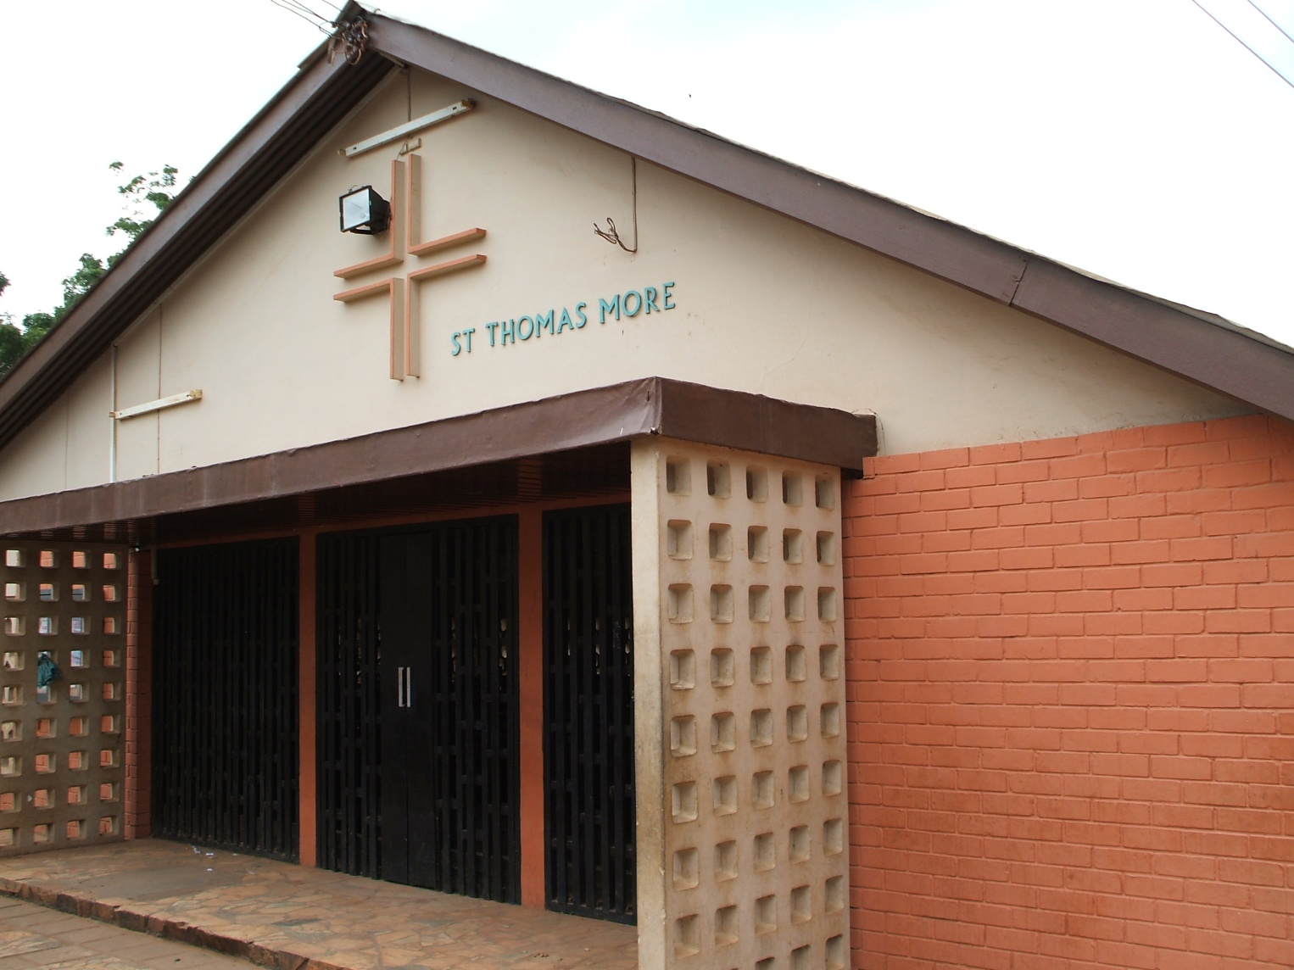
WEEKLY NEWSLETTER
5TH AUGUST, 2012: EIGHTEENTH SUNDAY IN ORDINARY TIME
THEME FOR THE WEEK: “”

Theme for the week: “All nations shall adore the Lord”

PASTORAL CARE
Sacrament of Confession: Every Saturday from 6.00pm to 7.00pm
Sacrament of Baptism of Infants: Second Saturday of every month. Please call at the Church’s office for a baptismal form. Instructions: Thursday preceding the date for baptism.
Visitation of the Sick and Aged: Thursdays at 7.00 am. Contact the office if you have a sick or aged Person(s) to be visited.
Sacrament of Marriage: Arrangements must be made at least six months to a year with the priests. The couple or one of them must be a registered member of the Church for at least 6 months.
Consultation of Priests: Monday, Tuesday Wednesdays (In the Evenings) Time: 6.30 - 8.00 pm. In case of any emergency call on the Priest.
Church office hours: Mon. to Thur.:10am -2pm & 5 pm - 8pm: Sat. 6 pm to 8p: Sun: 9 am -1.30: Friday: Off Duty

NEXT SUNDAY: 19TH SUNDAY IN ORDINARY TIME

Singing: 1st Mass: Ave Maria Singing group

2nd Mass: Youth choir

Offertory: 1st Mass: Ave Maria, X’tian Mothers and Individuals

2nd Mass: Youth Groups and individuals

SLOGAN: St. Thomas More: Besohwe! St. Thomas More: Justice and Truth!!
St Thomas More: Pray for us!
TODAY’S READINGS
1st Reading: Ex 16:2-4, 12-15
During the Exodus, the Israelites grew tired and ran out of food supplies. They grumbled against Moses and Aaron. God heard their complaints and rained down bread from heaven to feed the people.

Responsorial Psalm: Ps 78:3-4, 23-25, 54
THE LORD GAVE THEM BREAD FROM HEAVEN.

2nd Reading: Eph 4:17, 20-24
Paul exhorts the Ephesians to lay aside the old, pagan way of life and adopt a fresh spiritual way of thinking; in short, they must put on the new man Christ.
Gospel: Jn 6:24-35
When Jesus finds the crowd searching for him, he uses the creation to teach them not to work for perishable food but for the real heavenly food which is found in Jesus himself.

Reflection
God is the great provider; he cares for his people. The Lord will respond to our material needs. However, beyond our earthly needs is the well being of our souls which only Jesus the bread of life offers.

St. John Fisher: Pray for us (3x)

THANKS FOR WORSHIPPING WITH US. HAVE A BLESSED WEEK

READINGS FOR THE WEEK
- Mon 6th August 2012(The Transfiguration of the Lord)
Dan 7:9-10,13-14; Ps 97:1-2,5-6,9; 2Pt 1:16-19; Mk 9:2-10

- Tues 7th August 2012
Jer 30:1-2,12-15,18-22; Ps102:16-21, 29, 22-23; Mt 14:22-36

- Wed 8th August 2012
Jer 31:1-7; Ps /Jer 31:10-13; Mt 15:21-28

- Thurs 9th August 2012
Jer 31:31-34; Ps 51:12-15,18-19; Mt 16:13-23

- Fri 10th August 2012(St. Lawrence)
2cor 9:6-10; Ps 112:1-2,5-9;Jn 12:24-26

- Sat 11th August 2012
Hab 1:12-2:4; Ps 9:8-13; Mt 17:14-20

12TH AUGUST 2012
19TH SUNDAY IN ORDINARY TIME
1st Reading: 1 Kgs 19:4-8
Resp. Ps: Ps 34:2-9
2nd Reading: Eph 4:30-5:2
Gospel: Jn 6:41:51

KNOW MORE ABOUT YOUR FAITH

The Transfiguration of the Lord

Let us run there, eager and joyful, and let us be enveloped in the cloud, like Moses and Elijah, or James and John. Be like Peter, rapt at the divine vision, transfigured by the glory of the transfiguration, lifted high above the things of this world. Let us leave the flesh and creation behind and turn to the creator, to whom Peter in ecstasy said: ‘Lord, it is good for us to be here’.

Yes indeed, Peter, it is good for us to be here with Jesus and to remain here for ever. What is more blessed, what more sublime, what more exalted than to be with God, to be shaped to his likeness, to dwell in the light? Since each one of us has God within him and is transformed into his divine image, let us cry out in joy: “It is good for us to be here”.

For here all is light, and joy, and happiness, and bliss; here the heart is at rest, in peace, serene; here we behold Christ our God; here he comes to dwell with the Father, and as he enters he says: “ Today salvation has been brought to this house”; here with Christ are the countless treasures of eternal blessings; here are the beginnings of the age to come, here we see it reflected as in a mirror. (from a sermon of Anastasius of Sinai)
Pos/Days | 1st wk | 2nd wk | 3rd wk | 4th wk | 5th wk | Totals
1st Fri | 981.90 | 250.00 | 204.10 | 15.00 | 1110 | 2,561.00
2nd Wed | 976.60 | 80.00 | 260.00 | 102.00 | 211.00 | 2,432.40
3rd Mon | 676.60 | 30.00 | 413.00 | 289.00 | 73.00 | 1,481.60
4th Sat | 720.10 | 124.00 | 498.00 | 65.00 | 0.00 | 1,407.10
5th Thur | 716.10 | 182.00 | 95.50 | 21.00 | 30.00 | 1,044.60
6th Sun | 511.50 | 52.00 | 201.00 | 155.00 | 0.00 | 919.50
7th Tue | 639.8 | 0.00 | 43.00 | 120.00 | 0 | 802.80
Totals | 5,222.60 | 718.00 | 1,714.60 | 767.00 | 1,424.00 | 10,649.00

ANNOUNCEMENTS
- Monday, 6th August 2012 is the Transfiguration of the Lord. There will be Mass in the evening at 7:00 pm. The Main Choir will be in attendance.
- There will be inaugural Mass for New Achimota community on Friday 10th August 2012 at 7:00 pm.

- Parishioners are reminded of the GH¢50.00 per parishioner per month voluntary project. Contact Ms. Helen Quaye 0244280526. Email helenquaye@yahoo.com
- Do you want to learn French at your convenience and at a cheaper price? Contact Lambert on the following numbers: 0245736529: 0279608900
- A young graduate with Diploma in Marketing is seeking for employment. Anyone who can be of help should contact him on 0242152862
- Bible sharing every Wednesday at 7.00 pm at St. Thomas More( Acts8:4-25)
- Marriage Banns: Between: A.Cardell Richard West and Francisca Akosua Dzagbo(2nd time). B. Alfred Ellis Arthur and Madonna Jamila Malik(2nd time)
- Next Sunday’s Second collection will be for Saint Vincent de Paul.

DETAILS WITH POSITION OF THANKSGIVING FOR JULY 2012

Thank you all for your generosity. May God bless you!

DETAILS OF LAST SUNDAY’S COLLECTION

29/07/2012 | 1st MASS | 2nd MASS
Main collection | GH¢ 743.85 | GH¢622.65
2nd Collection | GH¢465.80 | GH¢294.10
Tithe | GH¢ 156.00
YOUTH CORNER
Health benefits of eating Bananas (Cont.)
Healthy Bones
Bananas are an exceptionally rich source of fructocliosaccharide, a compound that nourishes probiotic (friendly) bacteria in the colon. These beneficial bacteria produce enzymes that increase our digestive ability and protect us from unhealthy bacteria infections. Thanks to fructooligosaccharides, probiotic bacteria can increase both in number and functionality, increasing our body's ability to absorb calcium.
In addition, green bananas contain indigestible short chain fatty acids (SCFAs) that are very nutrient to the cells that make up the mucosa of the stomach. These cells, when healthy, absorb calcium much more efficiently
Healthy Kidney
About 190,000 cases of kidney cancer are diagnosed each year.
Research published in the International Journal of Cancer has shown that daily consumption of whole fruits and vegetables, especially bananas, is highly protective to kidney health. The results show that, over a long timeframe (13.4 years), women eating more than 2.5 servings of fruits and vegetable per day cut their risk of kidney cancer by 40%. Among the fruits, bananas were especially protective. Women eating bananas four to six times a week halved their risk of developing the disease compared to those who did not eat this fruit.

UPCOMING EVENTS

- Youth Harvest: 12th August 2012
- Solemnity of Assumption: 15th August 2012
- Laity Week: 19th – 26th August 2012

MEETINGS
- CPC executives will meet after the second Mass at SJF.
- Ave Maria society will have their general meeting next Sunday after 1st Mass at STM.

WEEKDAY MASSES

MONDAY: Evening Mass at 7:00 pm
TUESDAY: Morning Mass at 6.15 am
WEDNESDAY, Morning Mass at 6.15 am
THURSDAY: Morning Mass at 6.15 am
FRIDAY: Community Mass at 7:00 pm

