.
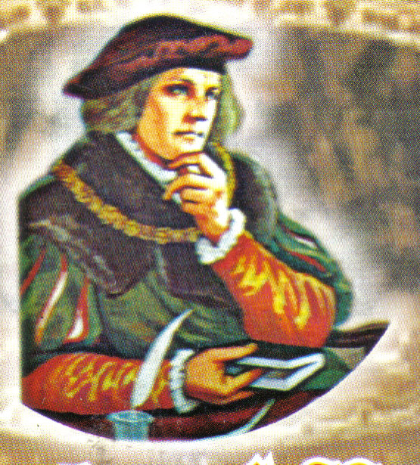

P.O. BOX AH 283, ACHIMOTA-ACCRA
Website: www.thomasmoreachimota.com E-mail:besohwe@yahoo.com Office Tel: 0201-775453
Rev. Fr. George Obeng-Appah (Priest-in-charge) Tel: 0208-592020
Rev. Fr. Blaise Bobi-Attachie
WEEKLY NEWSLETTER
1st DECEMBER, 2013: FIRST SUNDAY OF ADVENT- A 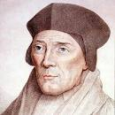
THEME FOR THE WEEK: BE READY

”
”

”

Theme for the week: “All nations shall adore the Lord”

TODAY’S READINGS

1st Reading: Is 2:1-5.
The happy future promised by God is not just for Jerusalem, or for the fortunate, the healthy and the wealthy in our society, but for all who seek the truth and who work for peace.

Responsorial Psalm: 122:1-2,4-9
WE SHALL GO REJOICING TO THE HOUSE OF THE LORD

2nd Reading: Rom 13:11-14
We can "wake from sleep" and "put on the armor of light" during this Advent season, if we resolve to live closer to the mind of Christ, and let him come more fully into our hearts.

Gospel: Mt 24:37-44.
We must accept the gifts and challenges each day brings, while trying to make ready for the day when Christ will come for the final judgment.

Reflection
Today, the first Advent Sunday marks the beginning of a period of preparation for the celebration of the birth of Christ, our Saviour, at Christmas. All the readings in the Mass advise us most urgently to make ourselves ready, to be on the alert, to turn aside from our sinful ways, and give more time to God in our lives. As we examine our consciences this advent and see our shortcomings we are privileged to receive the mercy of God in the sacrament of reconciliation. Let us not miss out on the grace God is offering us this advent.

ANNOUNCEMENTS

- There is Bible sharing this and every Wednesday at STM at 7:00pm.
- There are Good News Bibles are available in the office for sale.
- Funeral Announcement:
The death is reported of Mr. Sylvanus Anku-Vinyo. Details of the funeral are as follows; Burial Mass on 14th Dec 2013. Thanksgiving Mass on 15th Dec 2013 all at St Thomas More.
- There will be infant baptism on Saturday December 7 at 6:30am. Parents with infants to be baptised should pick up forms from the office and attend instructions with their Godparents on Thursday, 5th December at 5pm.
- There will be exposition of the Blessed Sacrament on Thursday 5th December From 6:15am to 7pm.
- St. Vincent De Paul Achimota Conference is Hosting Kpehe Deanery for a Retreat at STM on Saturday Dec 7th 2013 at 8: 30am. Members should take note and be there. New members are welcome.
QUIZ
Answer to last Week’s: Bishop Dominic Andoh

This week’s: How many Sundays are there in Advent?
QUOTE
God has two dwellings; one in heaven, and the other in a meek and thank heart
HARVEST 2013

- Parishioners are reminded to visit the harvest 2013 information desk to pay their harvest levy of 5 Cedis.

- The tiles for completing the floor space of St. John fisher are for sale. We are encouraged to purchase them in appreciation of the lives of loved ones. The cost is 20 Cedis per tile. Contact the information desk.

PASTORAL CARE
Sacrament of Confession: Every Saturday from 6.00pm to 7.00pm
Sacrament of Baptism of Infants: First Saturday of every month. Please call at the Church’s office for a baptismal form. Instructions: Thursday preceding the date for baptism.
Visitation of the Sick and Aged: Thursdays at 7.00 am. Contact the office if you have a sick or aged Person(s) to be visited.
Sacrament of Marriage: Arrangements must be made at least six months to a year with the priests. The couple or one of them must be a registered member of the Church for at least 6 months.
Consultation of Priests: Monday, Tuesday Wednesdays (In the Evenings) Time: 6.30 - 8.00 pm. In case of any emergency call on the Priest.
Church office hours: Mon. to Thur.:10am -2pm & 5 pm - 8pm: Sat. 6 pm to 8pm: Sun: 9 am -1.30pm: Friday: Off Duty

SUNDAY MASS: FIRST MASS - 7:00AM AT STM, SECOND MASS - 9:30AM AT SJF

NEXT SUNDAY: SECOND SUNDAY OF ADVENT
Singing: First Mass: Ave Maria

Second Mass: Youth Choir

Offertory: First Mass:Ave Maria

Second Mass: Youth Groups

WEEKDAY MASS
Tuesday 6:15am
Wednesday 6:15am
Thursday 6:15am
Friday 7:00pm
Saturday 6:30am

UPCOMING EVENTS

- Advent Retreat 18 – 20 Dec 2013
- Nine Lessons & Carols 24th Dec 2013
- Encounter with Jesus 29th Dec 2013

SLOGAN: St. Thomas More: Besohwe! St. Thomas More: Justice and Truth!!
St Thomas More: Pray for us!!!

SLOGAN: St John Fisher: Besohwe!
St John Fisher: Justice and Truth!!
St John Fisher: Pray For Us!!!

THANKS FOR WORSHIPPING WITH US. HAVE A BLESSED WEEK.

READINGS FOR THE WEEK
- Mon 2nd December, 2013
Is 4:2-6; Ps 122:1-9; Mat 8:5-11

- Tues 3rd December, 2013
Is 11:1-10; Ps 72:1-2, 7-8, 12-13, 17;
Lk 10:21-24

- Wed 4th December, 2013
Is 25:6-10; Ps 23:1-6; Matt 15:29-37

- Thur 5th December, 2013
Is 26:1-6; Ps 118:1,8-9,19-21,25-27; Mat 7:21,24-27

- Fri 6th December, 2013,
Is 29:17-24; Ps 27:1, 4, 13-14;
Mat 9:27-31

- Sat 7th December, 2013
Is 30:19-21, 23-26; Ps 147:1-6

8TH DECEMBER, 2013

1st Reading: Is 11:1-10

Resp. Ps : 72: 1-2,7-8, 12-13,17

2nd Reading: Rom 15: 4-9

Gospel : Mat 3:1-12

KNOW MORE ABOUT YOUR FAITH

ADVENT AND ITS IMPORTANCE TO THE CHRISTIAN o

WHAT IS ADVENT?
In the Catholic Church, Advent is a period of preparation, extending over four Sundays, before Christmas. The word Advent comes from the Latin advenio, "to come to," and refers to the coming of Christ. This refers, first of all, to our celebration of Christ's birth at Christmas; but second, to the coming of Christ in our lives through grace and the Sacrament of Holy Communion; and finally, to His Second Coming at the end of time.

ORIGINS OF ADVENT
According to the Catholic Encyclopedia, Advent began sometime after the 4th century as a time of preparation for Epiphany, and not in anticipation of Christmas. Epiphany celebrates the manifestation of Christ by remembering the visit of the wise men and, in some traditions, the Baptism of Jesus. At this time new Christians were baptized and received into the faith, and so the early church instituted a 40-day period of fasting and repentance.

Later, in the 6th century, St. Gregory the Great was the first to associate this season of Advent with the coming of Christ. Originally it was not the coming of the Christ-child that was anticipated, but rather, the Second Coming of Christ.

By the Middle Ages, the church had extended the celebration of Advent to include the coming of Christ through his birth in Bethlehem, his future coming at the end of time, and his presence among us through the promised Holy Spirit. Modern-day Advent services include symbolic customs related to all three of these "advents" of Christ.

Traditionally Advent has been known as a "little Lent." As in Lent, Advent should be marked by increased prayer, fasting, and good works. While the Western Church no
KNOW MORE ABOUT YOUR FAITH
longer has a set requirement for fasting during Advent, the Eastern Church, both Catholic and Orthodox, continues to observe what is known as Philip's Fast, from November 15 until Christmas.
Traditionally, all great feasts have been preceded by a time of fasting, which makes the feast itself more joyful. Sadly, Advent today has supplanted by "the Christmas shopping season," so that by Christmas Day, many people no longer enjoy the feast.
The Advent Wreath
Perhaps the best known of all Advent symbols is the Advent wreath, a custom which originated among German Lutherans but was soon adopted by Catholics. Consisting of four candles (three purple and one pink) arranged in a circle with evergreen boughs (and often a fifth, white candle in the center), the Advent wreath corresponds to the four Sundays of Advent. The purple candles represent the penitential nature of the season, while the pink candle calls to mind the respite of Gaudete Sunday. (The white candle, when used, represents Christmas.)

Focus on the Liturgy
There are always four Sundays in Advent, though not necessarily four full weeks. The liturgical color of the season is violet or purple, except on the Third Sunday of Advent, called Gaudete or Rejoice Sunday, when optional rose vestments may be worn. The Gloria is not recited during Advent liturgies, but the Alleluia is retained.

The prophesies of Isaiah are read often during the Advent season, but all of the readings of Advent focus on the key figures of the Old and New Testaments who were prepared and chosen by God to make the Incarnation possible: the Blessed Virgin Mary, St. John the Baptist, St. Joseph, Sts. Elizabeth and Zechariah.

Let us prepare for the coming of the Son of God, praying with the Church: Come, Lord Jesus, do not delay!

YOUTH CORNER

YOUTH CORNER

FINANCE CORNER
Thank you all for your generosity. May God bless you.
DETAILS OF LAST SUNDAY’S COLLECTION

